Project Report: Student Digital Ambassador Course: CSE0001 - Digital Literacy
Student Name: Arush Gupta
Registration Number: 25BAC10011
Branch: B.Tech Electronics and Communication Engineering (ECE)
Batch: 2025–2029
University: VIT Bhopal University
Date: April 2, 2026

Table of Contents
- Task 1: Digital Literacy Awareness Infographic
- Task 2: Professional Digital Portfolio
- Task 3: Coding & Collaboration Platforms
- Task 4: Professional Communication & Etiquette
- Task 5: Cybercrime Case Study & Awareness

Task 1: Digital Literacy Awareness Infographic Tool Used: Canva
Topics Covered: Defining Digital Literacy, Essential Toolkits, and Online Safety.

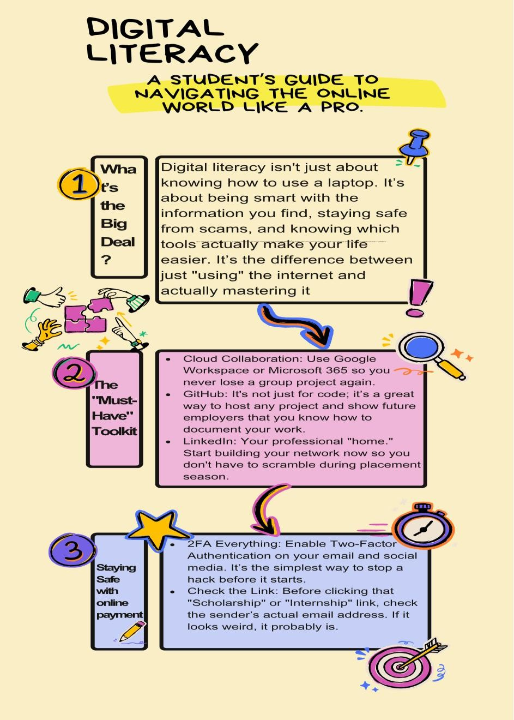Reflection: For this task, I
wanted to create a visual that felt approachable for any student, not just those in technical branches. I designed the infographic titled "Digital Literacy: More Than Just Googling" to highlight that being digitally literate is about mastery, not just usage. I focused on three pillars: the definition of literacy in a university context, the "must- have" tools like GitHub and LinkedIn, and critical safety habits like 2FA and the "UPI PIN Rule."
The process taught me that simplifying complex ideas is harder than it looks. I had to be very selective with my wording to ensure the most important safety tips—like checking email headers for phishing—stood out immediately. As a Student Digital Ambassador, I’ve realized that clear communication is our best defense against the rising number of digital scams. This task helped me bridge the gap between technical knowledge and practical, everyday safety for my peers.

Task 2: Professional Digital Portfolio
Platforms Used: GitHub, LinkedIn, and ResearchGate.
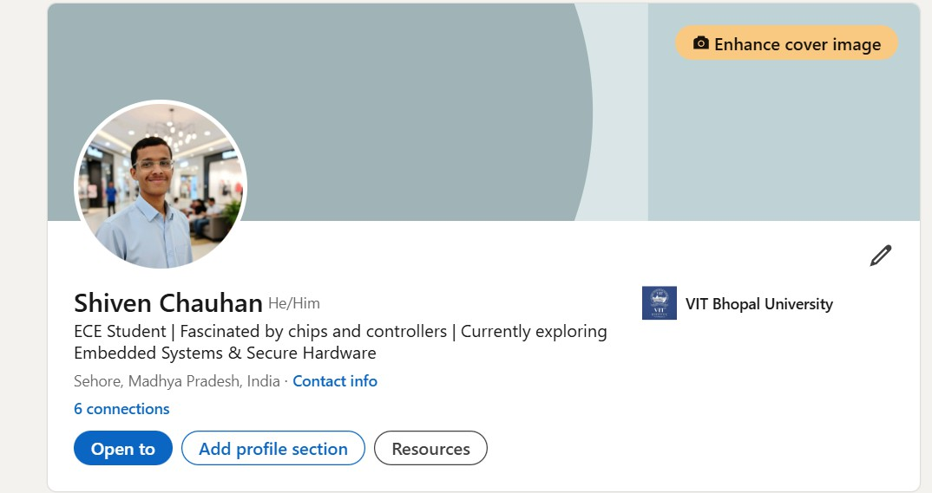
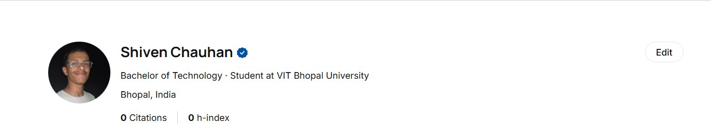
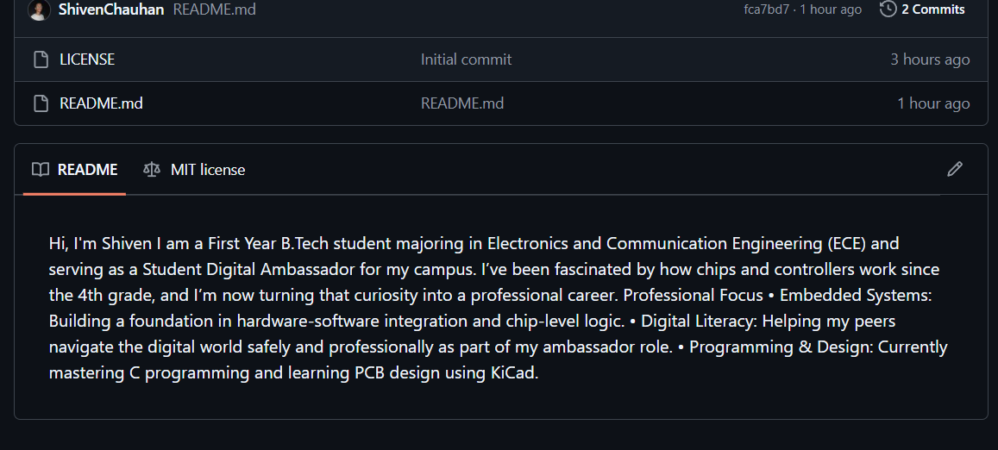

Reflection: Building a professional digital presence is essential for an ECE student looking to enter the industry. I chose GitHub, LinkedIn, and ResearchGate to create a balanced portfolio that covers code, networking, and academic research. GitHub is where I host my C programming and circuit design work, providing a "living resume"

for recruiters to see my actual progress. On LinkedIn, I updated my profile to reflect my current B.Tech status and my specific interests in embedded systems and secure hardware, ensuring I’m visible to the right professional circles.
I opted for ResearchGate because I’ve been fascinated by chips and controllers since the 4th grade, and I want to stay updated on the latest semiconductor research. This platform allows me to follow the work of experts in fields I hope to join one day. These three profiles now work together to show that I am technically capable, professionally connected, and academically curious.

Task 3: Coding & Collaboration Platforms Tools Used: HackerRank and Google Forms.
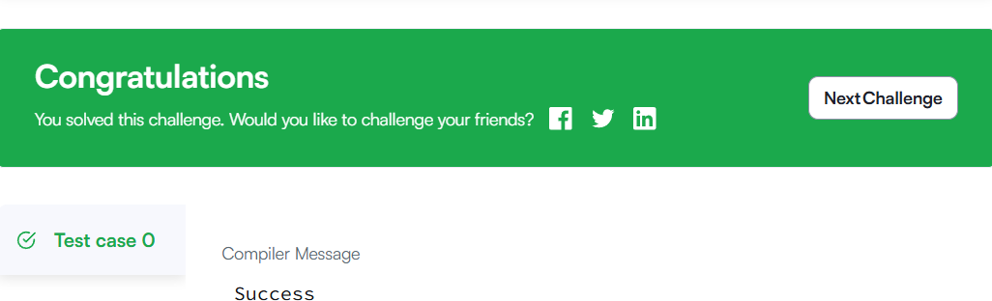
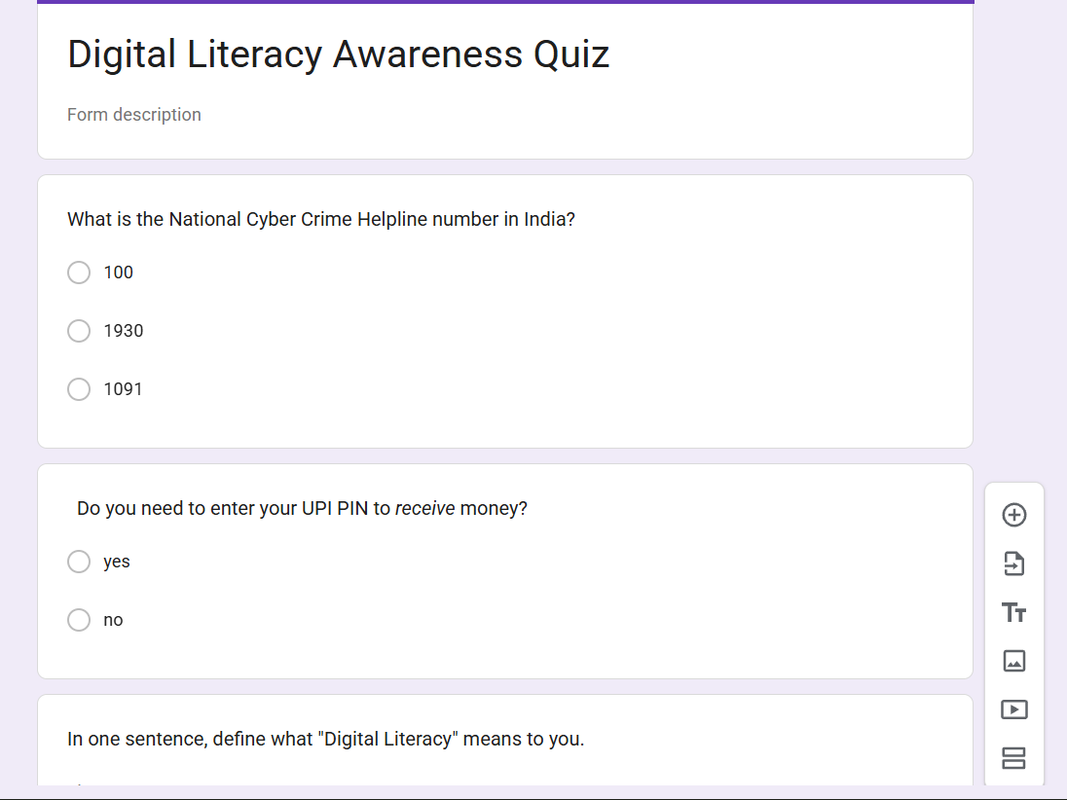

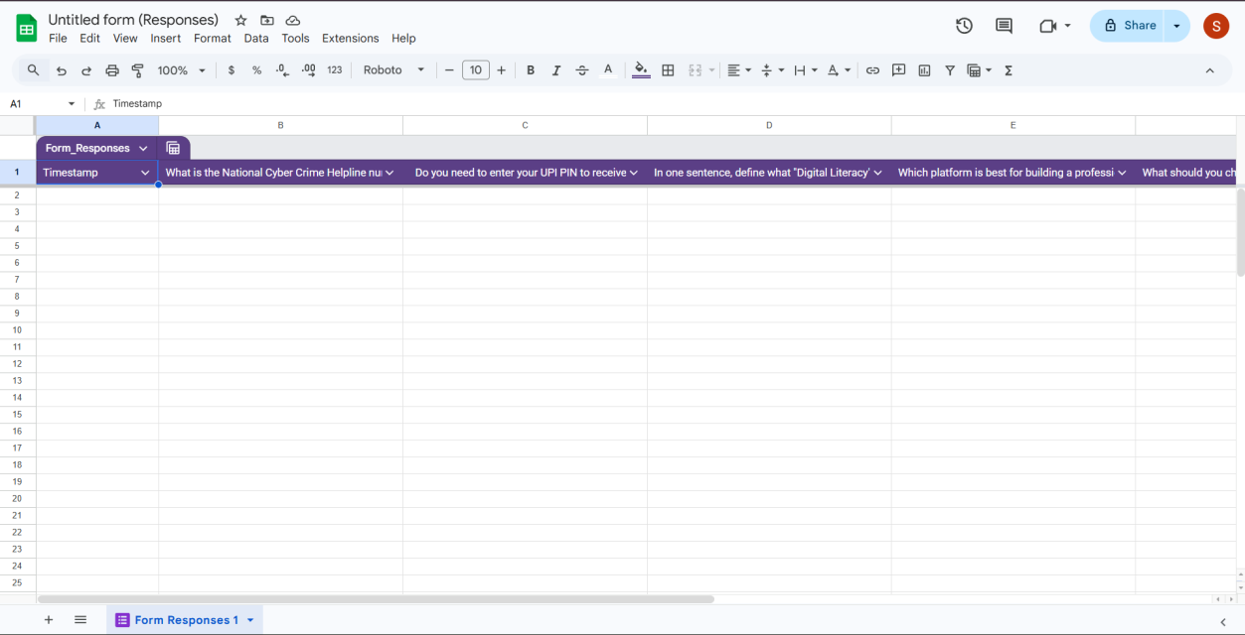
Reflection: This task allowed me to practice the "collaboration" side of digital literacy. I completed a beginner-level coding challenge in Python on HackerRank, which was a great way to see how automated platforms handle logic and syntax testing. Beyond coding, I designed a five-question "Digital Literacy Awareness Quiz" using Google Forms. This wasn't just about making a quiz; it was about learning how to collect, organize, and analyze data efficiently through a linked Google Sheet.
As a student who spends a lot of time on local coding environments, moving into cloud-based collaboration tools was eye-opening. I realized how much more productive group projects could be if we used these tools properly. This task reinforced the idea that being a "digital ambassador" means being comfortable with the platforms that allow us to work together seamlessly, whether we’re debugging a script or gathering feedback from a large group of people.

Task 4: Professional Communication & Etiquette
Deliverables: Extension Request Email, Internship Inquiry Email, and Social Media Checklist.

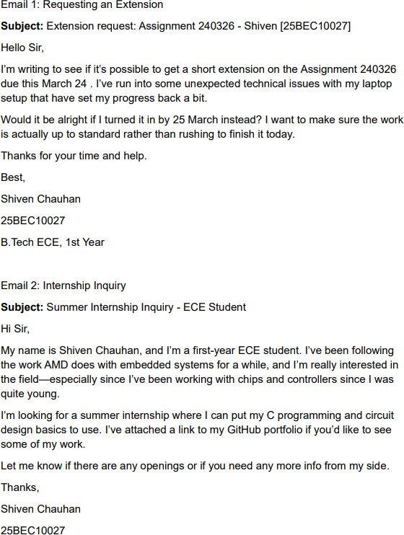
Reflection: Task 4 was about the "soft skills" of the digital world. I drafted two professional emails—one for a deadline extension and another inquiring about an ECE internship. I also created a social media checklist to ensure my online footprint remains professional and secure. One situation that really stood out to me was a group project where vague messaging led to the team bringing an incomplete physical circuit to a lab. It taught me that being brief is good, but being clear is better.
I’ve started applying these lessons to my daily life, especially when contacting faculty. I’ve noticed that using a clear subject line and a respectful tone leads to much faster and more helpful responses. For the social media part, I’ve become much more careful about what I share publicly and who can see it. It’s about building a "digital brand" that I’ll be proud of when I graduate in 2029.

Task 5: Cybercrime Case Study & Awareness
Deliverables: UPI Scam Case Study and Prevention Checklist.

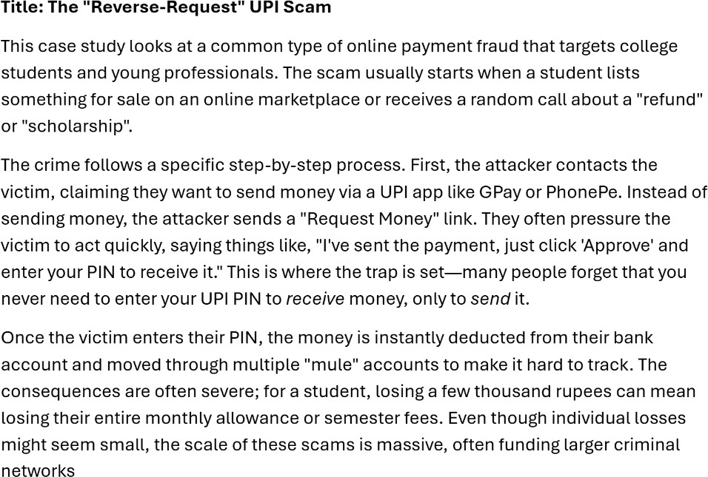
Reflection: For the final task, I researched the "Reverse-Request" UPI scam, which is unfortunately common among university students. I found that most cybercrimes succeed not because of a "hack" in the software, but because of a "hack" in human psychology— scammers use urgency and panic to trick people into entering their PINs. This research was a wake-up call for me. Even with my technical background, I realized how easy it is to make a mistake when you're in a hurry.
I’ve shared the "No PIN to receive" rule with my family and friends, as it’s the simplest way to prevent these types of losses. Being a Digital Ambassador has changed how I view my phone; I no longer see it just as a tool for games or study, but as a portal that needs constant protection. This project has given me the confidence to not only stay safe myself but also to help others navigate their digital lives without fear.

